Lab Exercise 11- Legal Hold Management in MinIO (Rocky Linux)

Objective
By the end of this lab, you will be able to:
- Understand Legal Hold vs Retention
- Enable Object Lock (WORM) on a bucket
- Apply Legal Hold ON / OFF on objects
- Verify delete protection
- Observe behavior with versions
- Understand compliance implications

Prerequisites
- MinIO server running
- mc client configured
- Admin/root credentials available

STEP 1 — Verify MinIO and mc Setup
Check alias:
mc alias ls
You should see:
local http://127.0.0.1:9000

STEP 2 — Create a Bucket with Object Lock Enabled
Legal Hold requires Object Lock.
mc mb --with-lock local/legalhold-bucket

STEP 3 — Enable Versioning (Mandatory)
mc version enable local/legalhold-bucket

mc version info local/legalhold-bucket

Expected:
Versioning is enabled

STEP 4 — Upload an Object
echo "Sensitive legal document" > case.txt
mc cp case.txt local/legalhold-bucket

List versions:
mc ls --versions local/legalhold-bucket

STEP 5 — Enable Legal Hold on the Object
mc legalhold set local/legalhold-bucket/case.txt
Verify:
mc legalhold info local/legalhold-bucket/case.txt
Expected:
Legal Hold: ON

STEP 7 — Attempt Delete with Bypass (Still FAIL)
Even in Governance mode, Legal Hold cannot be bypassed.
mc rm --bypass local/legalhold-bucket/case.txt

Expected:
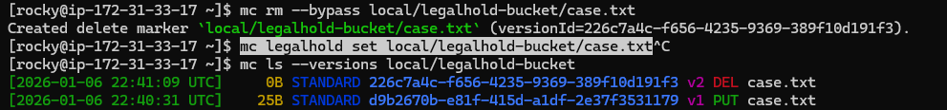
mc rm local/legalhold-bucket/case.txt --version-id d9b2670b-e81f-415d-a1df-2e37f3531179

Expected:

STEP 8 — Disable Legal Hold
Remove Delete marker
mc rm local/legalhold-bucket/case.txt --version-id 226c7a4c-f656-4235-9369-389f10d191f3

Clear legalhold
mc legalhold clear local/legalhold-bucket/case.txt

Verify:
mc legalhold info local/legalhold-bucket/case.txt
Expected:
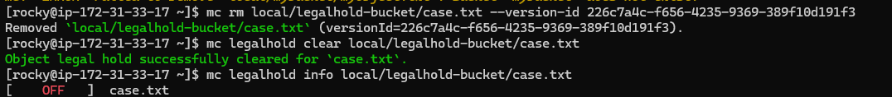
STEP 9 — Delete Object After Legal Hold Removal
mc rm local/legalhold-bucket/case.txt
Expected:
- Delete marker created
- Object becomes invisible
Verify:
mc ls --versions local/legalhold-bucket

Delete PUT version
mc rm local/legalhold-bucket/case.txt --ve rsion-id d9b2670b-e81f-415d-a1df-2e37f3531179

